Warframe fandom wiki robots.txt file:
https://warframe.fandom.com/robots.txt

https://warframe.fandom.com/wiki/Weapon_Comparison#All_Weapons

Preamble
This document serves as background information or reasoning to all the plots created while analyzing the data from Warframe Wiki. Due to where the data was obtained, not all words or phrases will make sense. An index will be included at the end defining these words. The data was obtained before Update 30.5. Any changes or additions to melee weapons base statistics are not included. The data is also accurate to what is found in-game because the game was unwilling to give out information in the past. The advice of many long-term players was to check this wiki for information pertaining to Warframe. All figures can be found in a second PDF file where it will be easier to see the various labels.

Question: What is the average DPS of melee weapons?
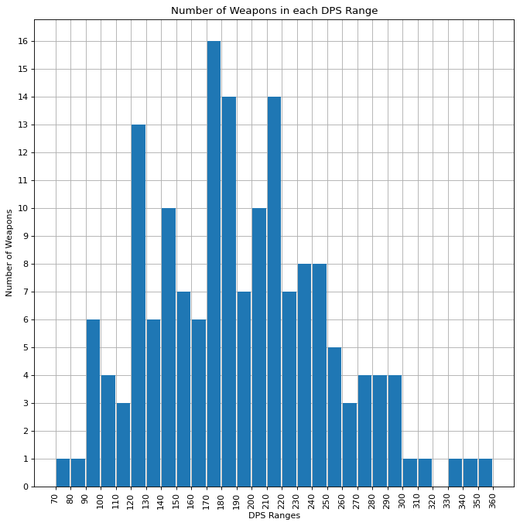
Warframe is a game created by Digital Extremes (DE) with a large variety of weapons to use. There are over 160 melee weapons to choose from; not all could be the best choice. The first way to compare the weapons is to compare their Damage Per Second (DPS). The base DPS or Raw DPS, as it is referred to in the graphs, is the product of the Total Damage of the weapon and the attack speed of the weapon. Figure 1 shows the number of melee weapons within certain DPS ranges.
Figure 1: This figure depicts the number of weapons within damage ranges of 10. The greatest number of weapons have a DPS between 170 and 180.
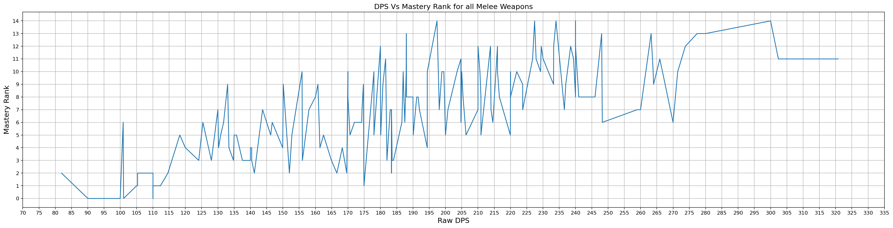
The mean and median for the Raw DPS is about 183 Damage Per Second. One of DE's previous balancing patches made an effort to balance the weapon's damage by its Mastery Rank. Mastery Ranks is effectively Account level in Warframe. DE used Mastery Rank as a means to restrict high damage weapons from low-level players encouraging them to use non-meta weapons. Figure 2 depicts all the melee weapons base DPS versus Mastery Rank; ideally, it should be a straight line.
Figure 2: This figure depicts the DPS versus the Mastery Rank of the weapon. It results in the graph being a spiky mess as the DPS does not line up with mastery rank.
The graph fails to account for the twenty-four weapon types, which have different damage ranges and attack speeds to make them feel more unique. Figure 3 shows only weapons in the hammer classification.
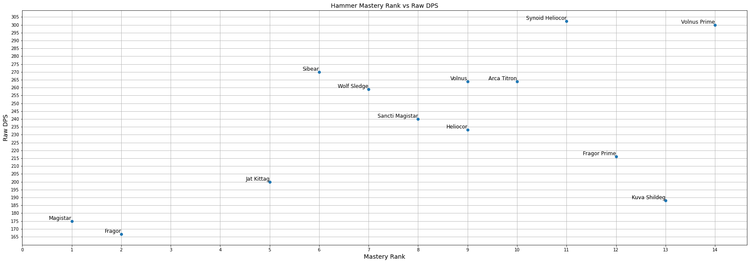
Figure 3: This figure shows the Mastery rank of the weapon versus the base DPS of the weapon. According to this graph, many of the hammers need a damage tweak. Fragor is an excellent example of a weapon needing a buff.
In the second document, a graph for each weapon type is included.

Question: Are weapons balance around base Critical Stats?
Base damage and attack speed are just one of the many ways weapons are balanced in Warframe. One of the other ways a weapon is balanced is through its critical chance and critical damage. Figure 4 shows the average critical damage a hammer will do over ten weapon hits. The average critical damage is obtained by finding the product of the critical chance of a weapon and 10. This will yield a number less than ten. Those case will then be the product of damage and the critical damage multiplier. The other case will only be the base damage.
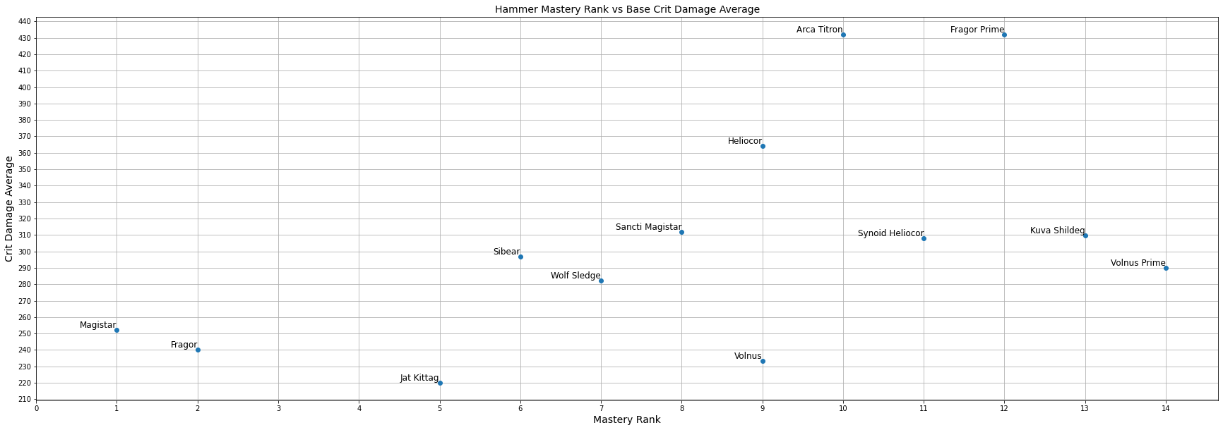
Figure 4: This Figure shows the average critical damage versus mastery rank for hammer type weapons. Fragor prime and the Arca Titron heavily rely on critical damage, while the Jat Kittag suffers from low critical chance or damage.
Here is the code used to create the average critical damage for further clarification.
def AverageCritDamage(df):
critaverage = df.Critical_Chance*10
tempdam = 0
for i in range(0,10):
if(i < int(critaverage)):
tempdam += df.Total_Damage*df.Critical_Damage
else:
tempdam += df.Total_Damage
return tempdam/10

Question: How bad was Update 30.5 for Blood Rush?
Upon the release of update 30.5, DE made some changes to some of the popular melee mods, one of these being Blood Rush. They wanted to nerf/weaken melee weapons, so their DPS was closer to that of guns. Blood Rush grants extra critical chance based on the combo counter resulting in a critical chance of 660% before the change and 440% critical chance after the change. Blood Rush allows many weapons to have a critical chance of over 100%. Figure 5 is two pie charts showing the number of weapons that can achieve over 100% critical chance before and after the nerf.
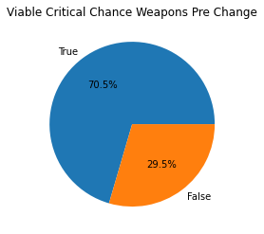
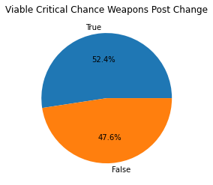
Figure 5: The figure on the left shows the number of weapons that can achieve 100% critical chance before the nerf. The right shows the number of weapons that can achieve 100% critical chance after the nerf.
Around 18% of the weapons could no longer achieve a critical chance of 100% or more after the nerf. This change will reduce the number of weapons considered viable for high level content. Figure 6 shows what happens to the critical damage before and after the nerf to blood rush for hammer weapons.
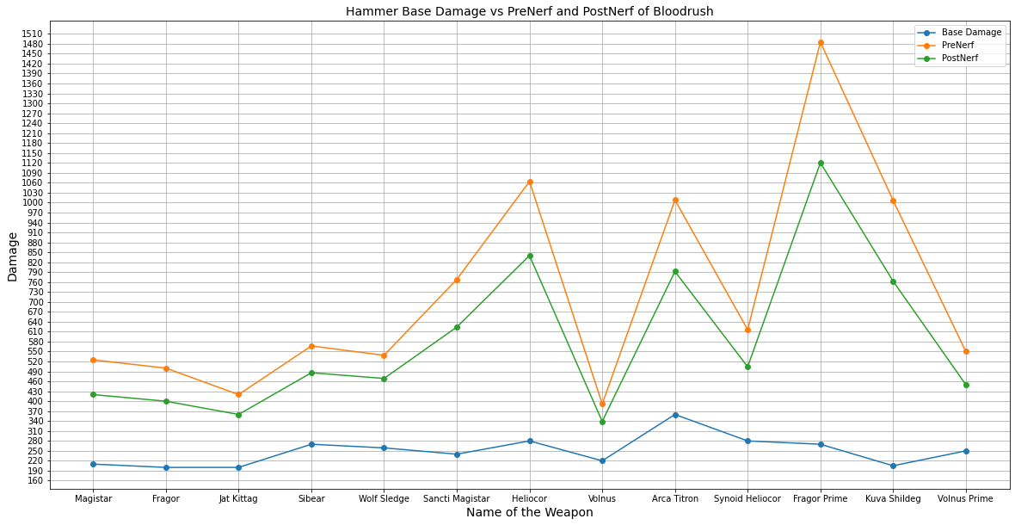
Figure 6: This figure shows the base damage, PreNerf critical damage, and PostNerf critical damage of hammer weapons. The base Damage is the blue line. The yellow line represents PreNerf critical damage, and the green line represents PostNerf critical damage. Fragor Prime benefits heavily from extra critical damage. It also suffered from a 25% decrease in damage after the nerf.
In the second document, each weapon type has the same graph available. Overall this change does reduce how much damage is gained from Blood Rush; however, it did not make the Volnus’ damage more in line with Fragor Prime’s damage. The weapons that work well with Blood Rush before the change still work well after it.

Question: How bad was Update 30.5 for Condition Overload?
Condition Overload is another one of the mods that were changed in update 30.5. Its damage per status was reduced from 120% to 80%. Another mod that does something similar to Condition Overload but does not have increasing damage is Primed Pressure Point; it increases damage by 165%. Now comparing Condition Overload to Primed Pressure Point, it would take only two statuses before the change to be better than Primed Pressure Point. After the nerf, it takes three statuses to achieve this effect. Figure 7 depicts the damage ramp before and after the nerf with Primed Pressure point as a control.
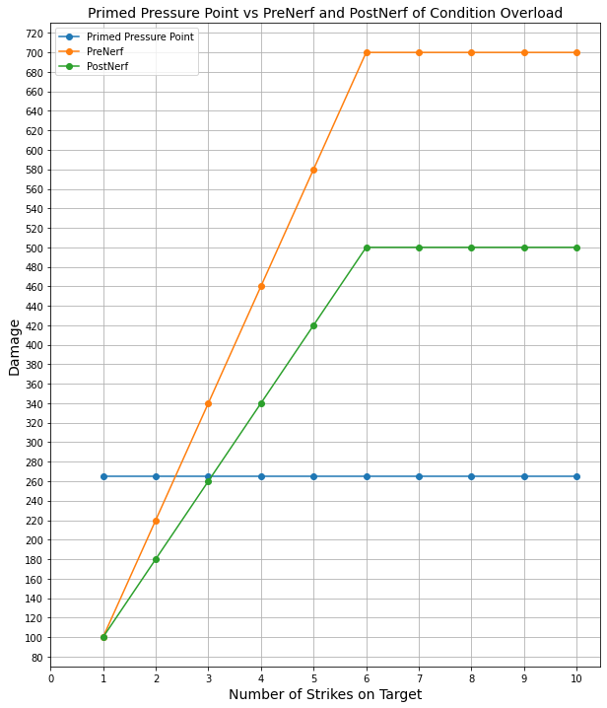
Figure 7: This Figure compares the damage of Condition Overload before and after the nerf with Primed Pressure Point be used as a baseline. Some assumptions are made in this graph first the damage of the weapon is 100. 100 makes it easier to apply the damage changes for example Primed Pressure Point multiplier is 1.65 which results in 165 damage plus the base 100 results in 265 damage. Next it is assumed that the target has zero statuses on them meaning Condition Overload starts at zero. The next assumption is that one unique status is applied after each strike with five being the max number of unique statuses. Five is chosen as most melee weapon can apply five statuses.
The changed version of Condition Overload can still be better than Primed Pressure Point but is now harder to achieve. Once again, this raises the bar on what weapons are viable for status builds.
Final Thoughts
The changes do shake up the meta but not for the better. Weapons that barely made the cut for this style of melee combat are not worthwhile. This change does weaken the top-performing weapons; however, the gun buffs are not adequate enough to bring them closer to being viable. Melee weapons are still king.
In terms of data analysis, this has been an interesting process to make the graphs and then to make them presentable. There is more to learn when it comes to Pandas, Matplotlib, and NumPy. I believe I am in a better position to tackle these challenges.
Index
Account Level: In games, level is a way to determine how strong a character is. Account Level refers to the player’s account strength.

Buff: This is a positive change to an item in a game. A common example is an increase in a stat like weapon damage going from 100 to 110.
Combo Counter: This is a counter for the number of melee hits landed on enemies. The counter goes up to 12 in Warframe.
Critical Chance: This is the chance to deal a critical hit. A critical hit takes the base damage and multiplies it by a multiplier usually know as Critical Damage.
Critical Damage: This is a multiplier used to increase the base damage when a critical hit is landed.
Damage Per Second(DPS): A useful unit in video games. It is a measure of damage over time. Game developers will balance around this. A big weapon may have high damage, but be slow to swing. Or a small weapon may attack very quickly, but it does little damage.
Digital Extremes (DE): The game developers for Warframe.
Meta: In this context, it is used to describe the most effective/popular weapons base on the tools available in the game.
Nerf: This is a negative change to an item in a game. Most commonly, a reduction in a stat, for example, changing the damage of a weapon from 110 to 100.
References
Weapon Comparison. WARFRAME Wiki. (n.d.). https://warframe.fandom.com/wiki/Weapon_Comparison#All_Weapons.

